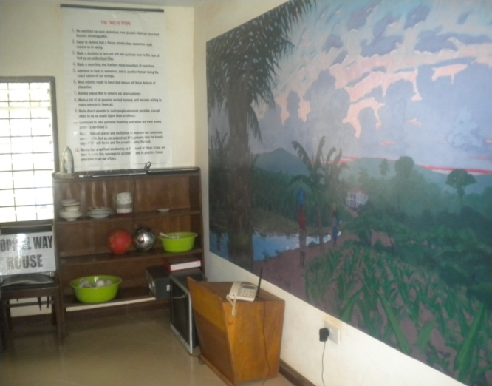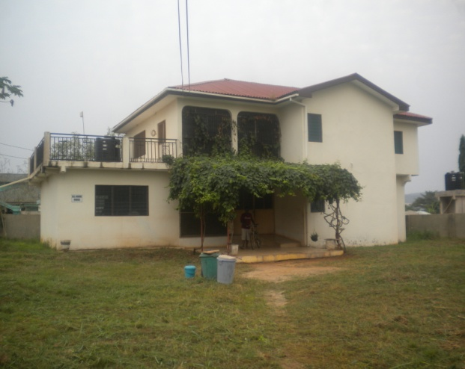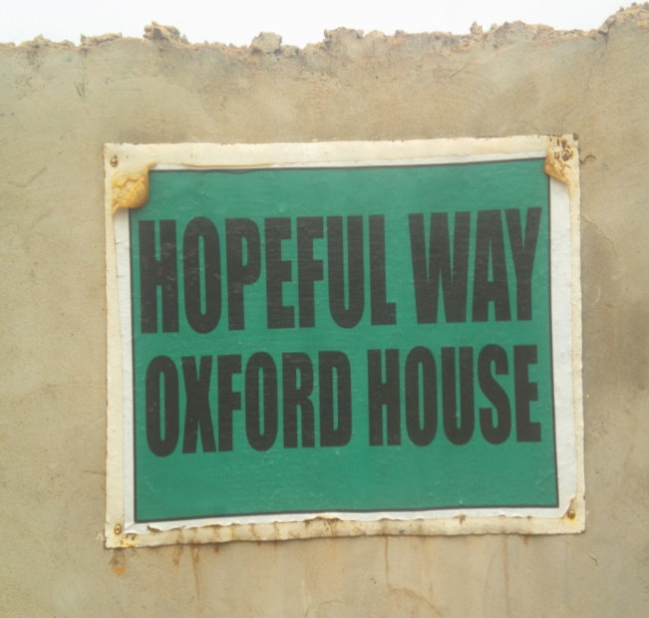

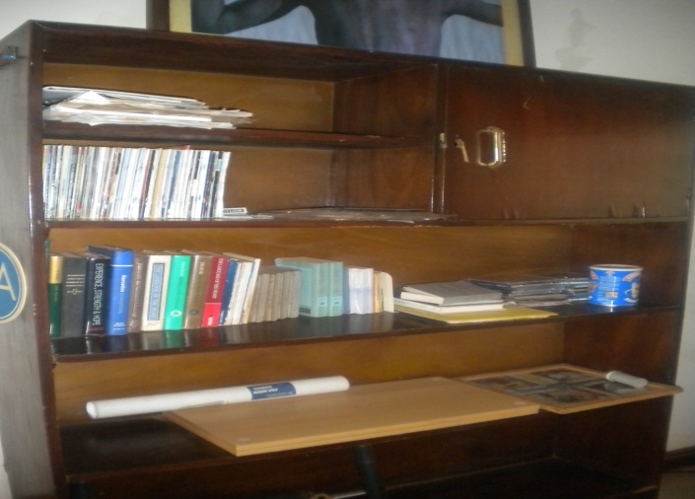

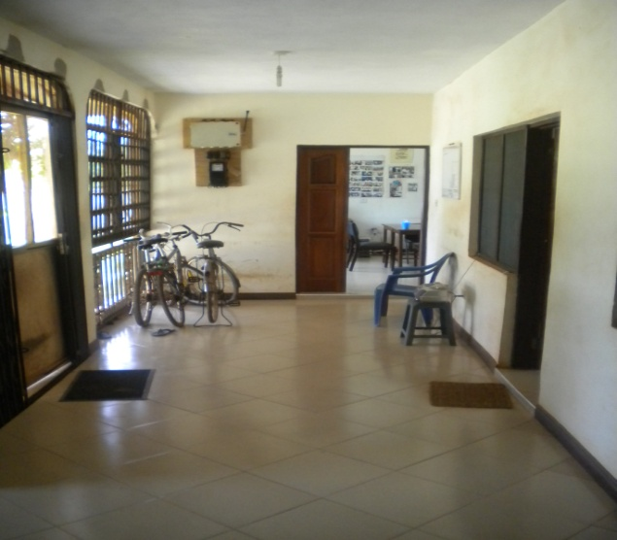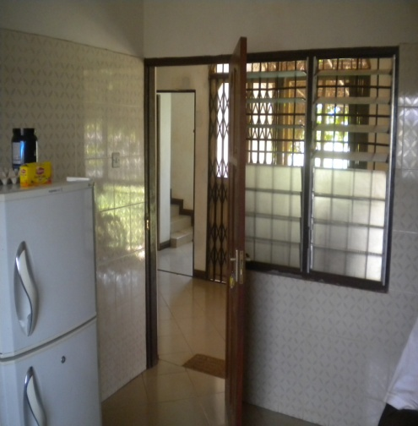

***HOPEFUL WAY OXFORD HOUSE.***

**Hopeful Way Oxford House is a transitional housing and rehabilitative support centre for the alcoholic and drug addict who wants to stop drinking or using drugs and stay sober. The main objective of this house is to create a safe home where recovery from the disease of alcoholism and drug addiction is understood and the need to stay away from the first drink or drug fix is emphasized. The bond that holds us together is the desire to stop drinking or using drugs and staying sober. Modest rooms and living facilities can become luxurious suites when viewed from an environment of alcoholics and drug addicts working together for comfortable sobriety. The house is a democratically self-run, financially self supporting and expels any resident who uses alcohol and or drugs. There are five officer roles namely: The President, the Secretary, the Treasurer, the Comptroller and the Chore Coordinator.**

**All new members are placed on a probationary contract lasting anywhere from thirty days to ninety days. During this period, the member is required to do 12 step work with the help of a sponsor, attend Alcoholics Anonymous (A.A) and Narcotics Anonymous (N.A) meetings 5 times per week, is not allowed to travel outside the house alone and follow other standard house rules. The house can democratically tailor the contract with additional requirements (i.e. Cell phone usage, meeting attendance, etc.)Done on a case by case basis. Some of the features of the Oxford House is: a large family room with a library stocked with recovery literature, a large kitchen, 24 hour internet service, seven bedrooms each with at least two beds.**

**There are three cardinal rules in the house which when violated will lead to the eviction of a resident:**

1. **NO using and or drinking anytime, anywhere.**
2. **NON-payment of shared expenses (rent and fines) is unacceptable.**
3. **NO disruptive behavior.**

**If the aforementioned rules are followed, a member can live in our home as long as he desires.**

**For a person to be admitted in the Oxford House, an interview is conducted for verification and identification. After the interview process, current members of the house vote (Must get at least 80% of the members vote count).The move in fee is GHC50, plus a three months’ rent of GHC 420 (GHC 140/month) plus a first month of monthly contributions fee of GHC25 per month covering utilities and basic household needs plus a urinalysis/breathalyzer testing fee of GHC 100 bringing the total amount to GHC 595.**

**We believe that alcoholism and drug addiction are chronic and progressive diseases that can be treated. Persons who have been treated in Accra’s hospitals and clinics often need to be placed in a protective environment before returning to the communities. Going back to the places where they came from often leads to relapse.**

For more information OR to schedule an interview, call

0206266436 OR 0546644541

House No. 0332095276

**Ask for Henry OR Ishmael**

**Oyarifa-Hopeful Way Oxford House**

**Near Pantang Junction**